Project Documenation for CareerMap

1. **Project Charter:**
   1. **Purpose:**

The aim of this project is to create a complete job board application that easily and effectively links job seekers and employers. A platform to look for jobs, apply for jobs, and manage applications is offered by the application to job seekers. It provides an application management system and job posting tool for employers. Application processing, job postings, and user authentication are all handled by the project's backend, which is created with Spring Boot. Updates in the future will add the frontend functionality, which allows employers to post new jobs, while the backend has been completed. By doing this, employers and job seekers will have a seamless, end-to-end experience.

**1.2 Objectives**

1. Developed a secure backend using Spring Boot to manage user authentication, job postings, and application processing.
2. Built a responsive and dynamic frontend using React, providing an intuitive user interface for both job seekers and recruiters.
3. Integrated MySQL database for managing and storing data related to users, jobs, and applications.
4. Ensured secure and efficient data management through validation, error handling, and secure authentication.
5. Facilitating seamless navigation and interaction between users and recruiters with features like job search, filtering, and application management.

**1.3 Timeline:**

**Hour 1-3: Backend Enhancements:**

* 1. Focus on completing and refining backend functionalities. This includes ensuring that all RESTful APIs for job posting, job search, user authentication, and job applications are fully functional and optimized.
  2. Implement any remaining logic to support features like posting new jobs, managing user roles (employer and job seeker), and storing and retrieving data efficiently from the database.
  3. Test the backend endpoints thoroughly to ensure they are correctly interacting with the database and returning expected results, with a focus on stability and performance.

**Hour 3-6: Frontend Development:**

* 1. Developed and finalized the frontend features using React. Specifically, work on completing the job posting interface. Including the ability to input job details and submit them to the backend.
  2. Enhance the existing frontend components for job search, filtering, and job application processes.Seamless user experience with intuitive navigation, clear feedback, and responsive design.
  3. Integrated the frontend with the backend APIs to make sure data flows correctly between the client and server, enabling full functionality of all features.

**Hour 6-10: Testing and Debugging:**

* 1. Conducting comprehensive testing of both the frontend and backend components to identify and fix any bugs or issues.
  2. Tested all user flows, such as registering, logging in, searching for jobs, applying for jobs, and posting new jobs, to ensure they work as expected.

**2.1 Scope of Work:**

The scope of this project includes developing a job board application where users can search for jobs, apply for jobs, and employers can post new job openings. The project will involve the following key tasks:

1. **Backend Development**:
   1. Created and refining a backend system using Java Spring Boot that manages job postings, user registrations, authentication, and job applications.
   2. Implemented RESTful APIs to handle data interactions between the frontend and the database.
   3. Ensuring secure storage and retrieval of data, such as job details, user profiles, and applications.
2. **Frontend Development**:
   1. Built a user-friendly interface using React for job seekers to search and apply for jobs.
   2. Implementing features like job search filters (by location, job type, salary, etc.), and displaying job details and application status.
3. **Database Integration**:
   1. Setting up a relational database (MySQL) to store and manage data related to users, jobs, applications, and companies.
   2. Creating database schemas to handle different data entities, including tables for users, jobs, applications, and company details.
   3. Establishing a connection between the backend server and the MySQL database to ensure smooth data storage and retrieval operations.
   4. Writing queries and utilizing Spring Data JPA for efficient data manipulation and management, such as creating, reading, updating, and deleting records.
   5. Implementing data validation and integrity checks to ensure that the data stored in the database is accurate, consistent, and secure.
4. **Integration**:
   1. Connecting the frontend with the backend APIs to ensure smooth data flow between the client and server.
   2. Validating that all features, such as user registration, login, searching, and applying, work seamlessly with the database.
5. **Testing and Debugging**:
   1. Conducting thorough testing of all components,end-to-end tests to identify and fix bugs or issues.
6. **Finalization**:
   1. Refining and optimizing both the backend and frontend based on feedback and testing results.
   2. Preparing the application for deployment, ensuring that it is fully functional, secure, and ready for use.

**2.2 Deliverables:**

The following are the key deliverables for the job board application project. These deliverables represent the major outcomes that will be produced and provided at various stages of the project:

1. **Backend API**:
   1. A fully functional backend built with Java Spring Boot.
   2. The backend will include RESTful APIs to handle user registration, authentication, job postings, job searching, and job applications.
   3. The API will securely manage and process data, ensuring proper communication between the client (frontend) and the server.
2. **Frontend Application**:
   1. A user-friendly web interface developed using React that allows users to interact with the job board.
   2. Key features will include job search functionality with filters (by location, job type, salary, etc.), user authentication, job application submission.
   3. The frontend will be responsive, ensuring that the application is accessible and usable on a wide range of devices, including desktops, tablets, and smartphones.
3. **Database Integration**:
   1. A well-structured MySQL database to store all necessary data, including user profiles, job postings, job applications, and company details.
   2. The database will be integrated with the backend API to ensure efficient data management and retrieval.
   3. Proper data schema and relationships will be established to ensure data integrity, consistency, and security.

**2.3 Acceptance Criteria**

* 1. All APIs are functional, secure, and return correct responses.
  2. The frontend must provide a smooth user experience, with features like job filtering, application management, and real-time job updates.

**3. Requirements Documentation:**

**3.1 Target Audience:**

* 1. Job Seekers: Individuals searching for job opportunities across various industries.
  2. Recruiters: Employers and recruitment agencies looking to post job openings and manage applications.

**3.2 Key Messages:**

* 1. "Your next job is just a click away! Discover and apply to jobs effortlessly."
  2. "Simplify your recruitment process with our efficient job management tools."

**3.3 Functional Requirements:**

* 1. User Authentication: Allow users to register, log in, and manage their profiles securely.
  2. Job Search and Filtering: Enable users to search for jobs by title, location, salary, and type.
  3. Job Application Management: Allow users to apply for jobs and manage their applications.

**3.4 Non-Functional Requirements:**

* 1. Performance: Ensured the application loads in less than 3 seconds under normal load.
  2. Security: Protect user data using HTTPS, authentication, and secure database queries.
  3. Usability: The application is easy to use, with a simple and intuitive interface.

**4. Project Plan:**

**4.1 Milestones:**

**Milestone 1:**

* 1. Finished all backend functionalities, including:
  2. Development of RESTful APIs for handling job postings, user authentication, job applications, and search functionalities.
  3. Integration of the MySQL database to store job details, user data, and applications.
  4. Ensured backend services handle CRUD operations effectively.
  5. Testing all backend services locally to confirm they work as expected.
  6. Fixing bugs and issues identified during testing.

**Milestone 2:**

* 1. Complete the user interface development using React:
  2. Implement pages such as Job Listings, Job Application, User Login/Signup, and Profile Management.
  3. Ensure smooth integration with backend APIs for fetching and submitting data.
  4. Develop the search and filter functionalities for jobs.
  5. Tested the frontend thoroughly to ensure all components are working correctly.
  6. Make necessary adjustments based on testing results.

**Milestone 3:**

* 1. Ensured the application handles edge cases and error states gracefully.
  2. Fixed bugs and issues discovered during the testing phase.
  3. Conformed that the application is secure, performant, and free from major vulnerabilities.

**4.2 Resource Allocation:**

**Backend Development (Hour 1-3):**

* 1. Design and implement the backend architecture.
  2. Develop RESTful APIs for user authentication, job posting, job application, and job search functionalities.
  3. Integrate the MySQL database to handle data storage and retrieval efficiently.
  4. Conduct initial testing of backend functionalities to ensure they work correctly.

**Frontend Development (Hour 3-6):**

* 1. Built the user interface using React, including pages for Job Listings, Job Application, User Login/Signup, and Profile Management.
  2. Ensure the frontend communicates effectively with backend APIs.
  3. Designed responsive and user-friendly layouts.
  4. Tested the frontend components and adjustmented as needed.

**Testing and Quality Assurance (Hour 6-10):**

* 1. Conducted end-to-end testing of the complete application to identify and fix bugs.
  2. Ensured the application meets all defined requirements and acceptance criteria.
  3. Made final refinements and optimizations based on testing feedback.

**4.3 Results:**

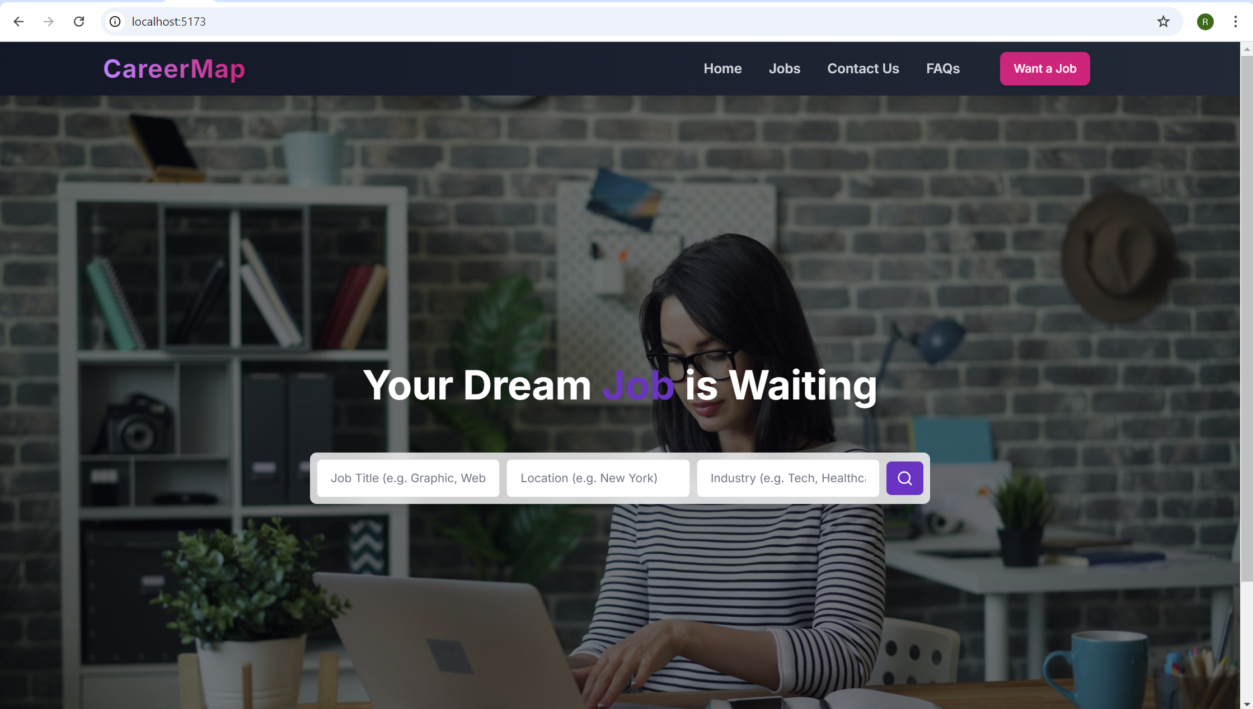

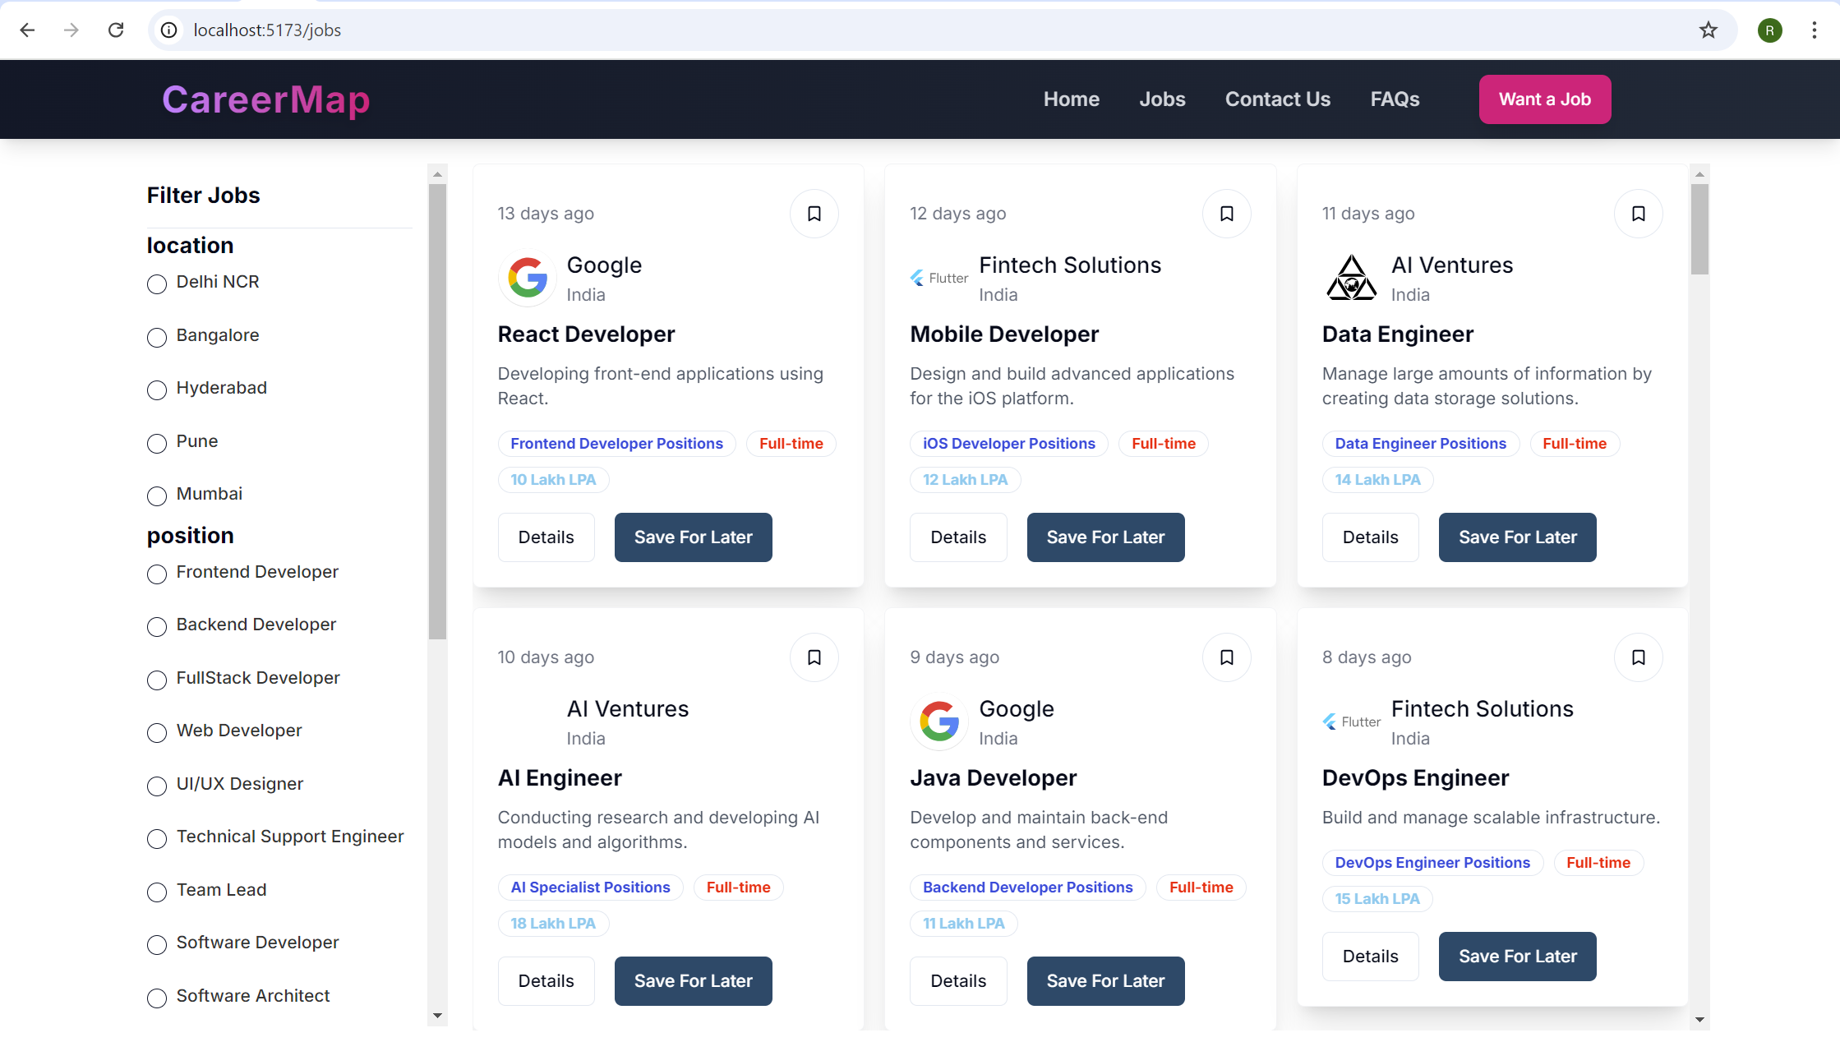

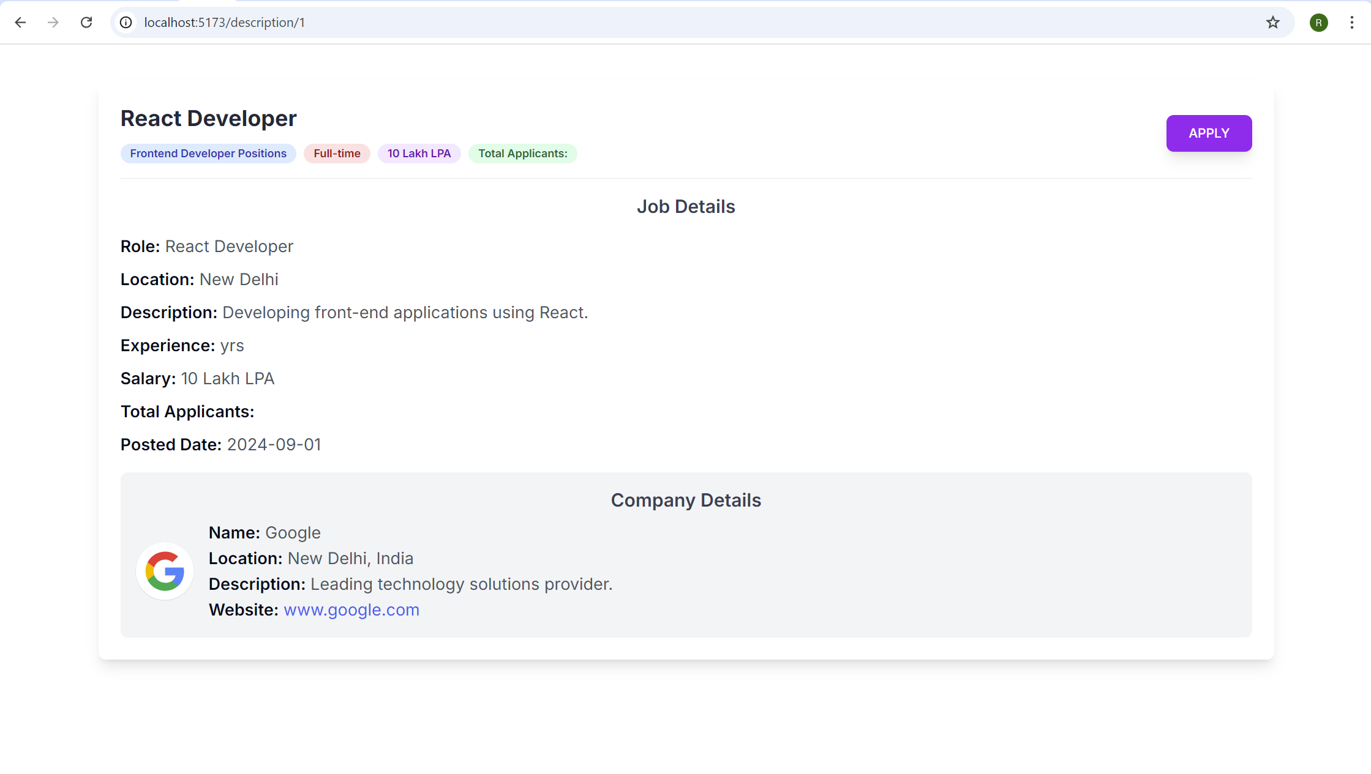

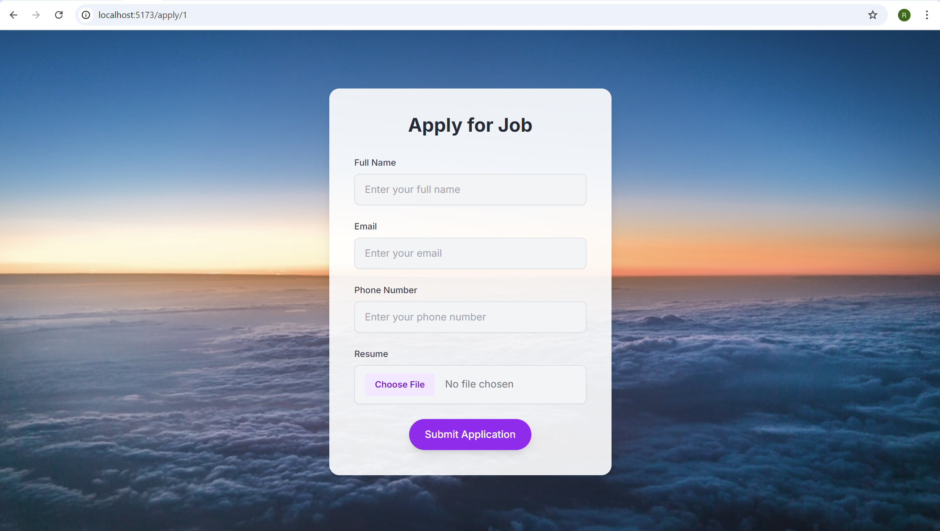

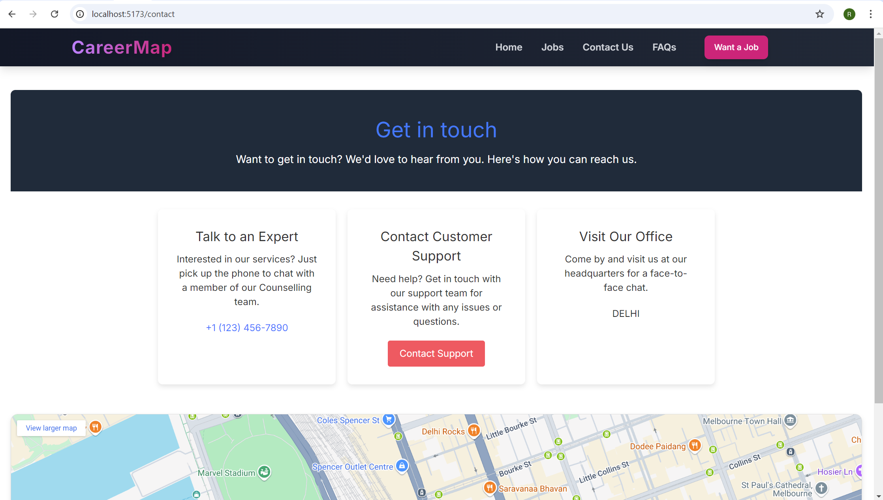

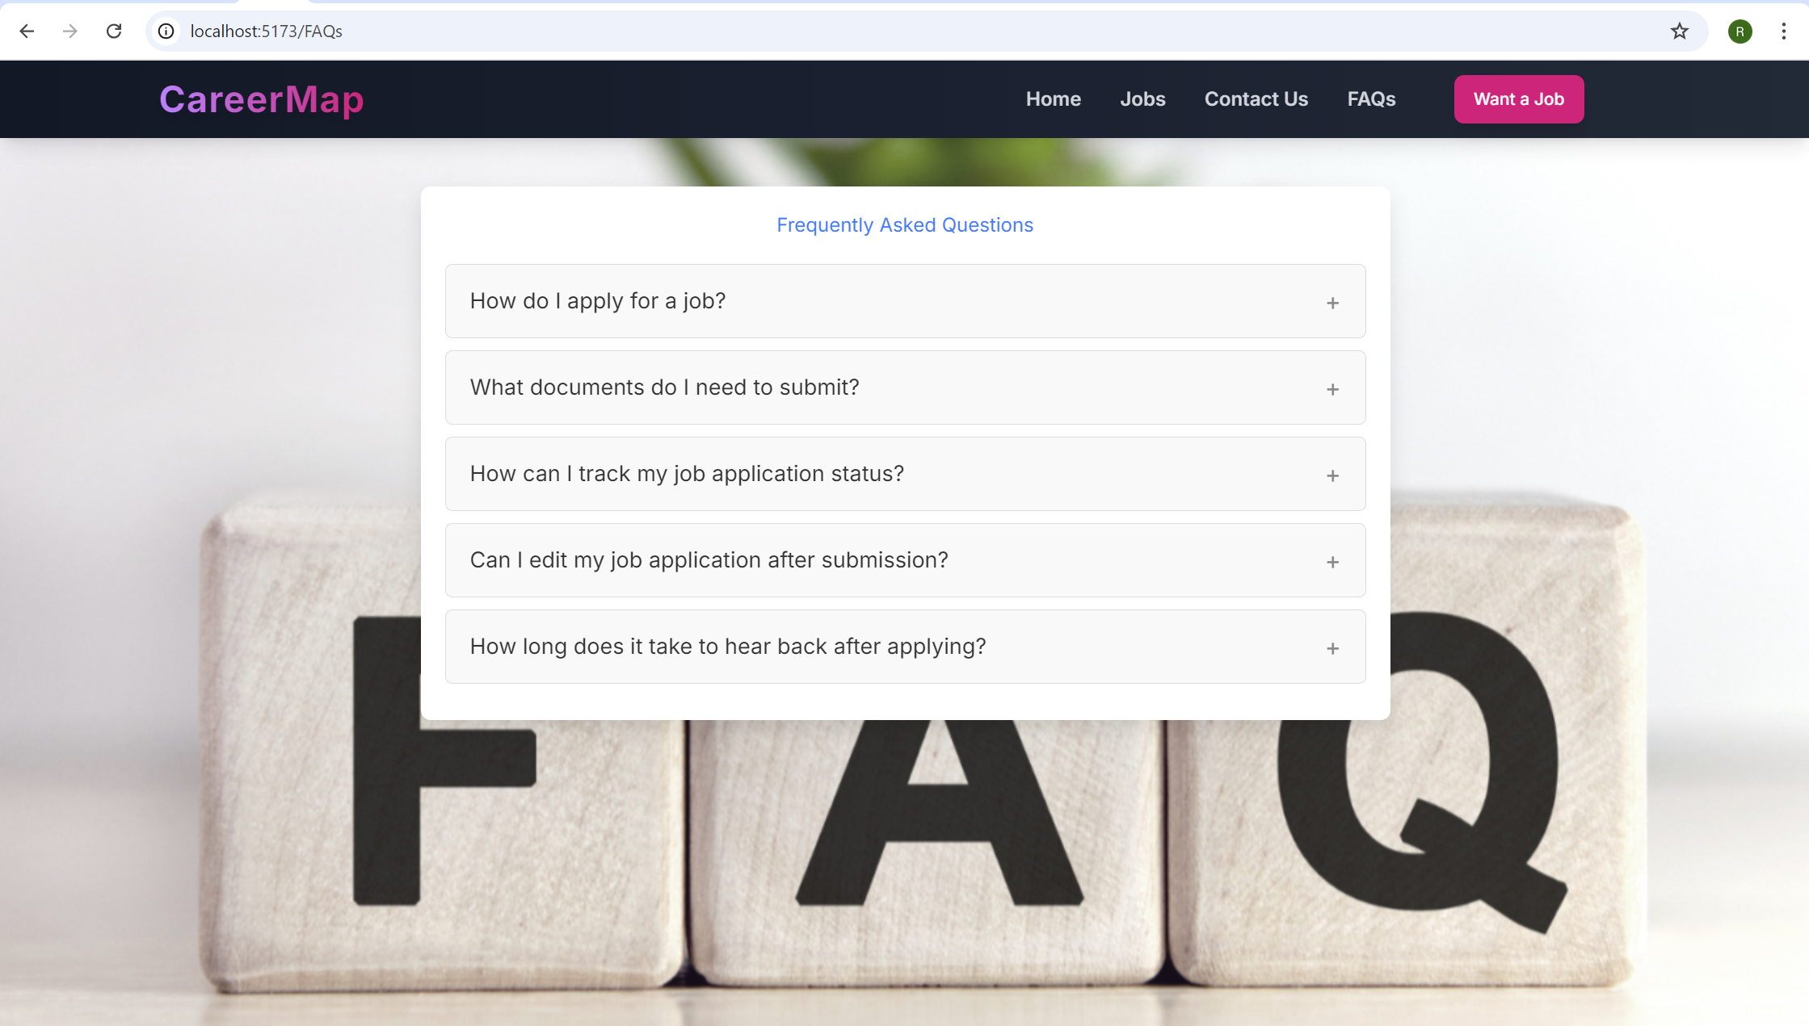

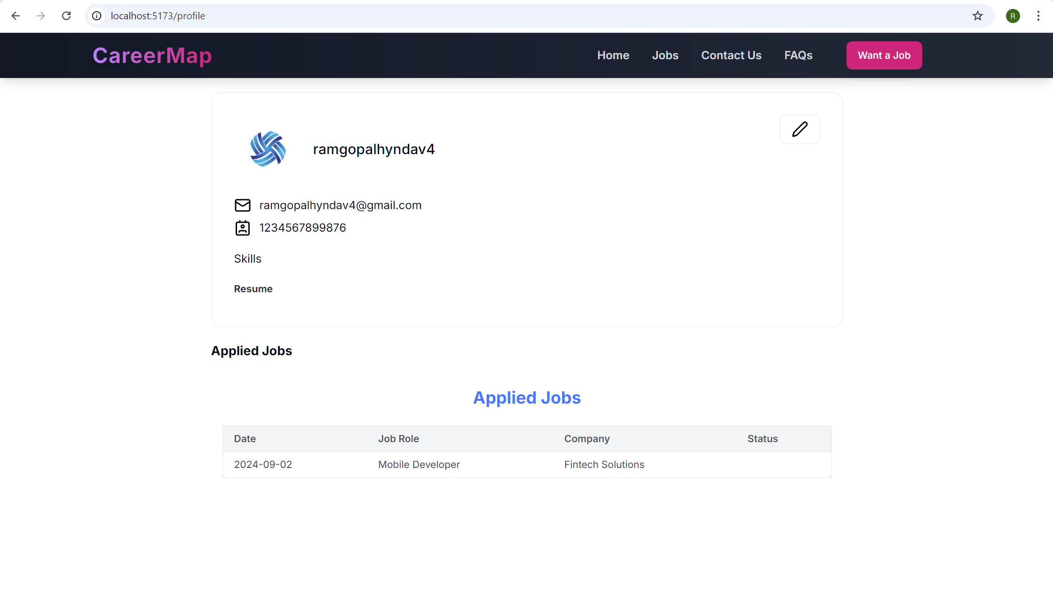

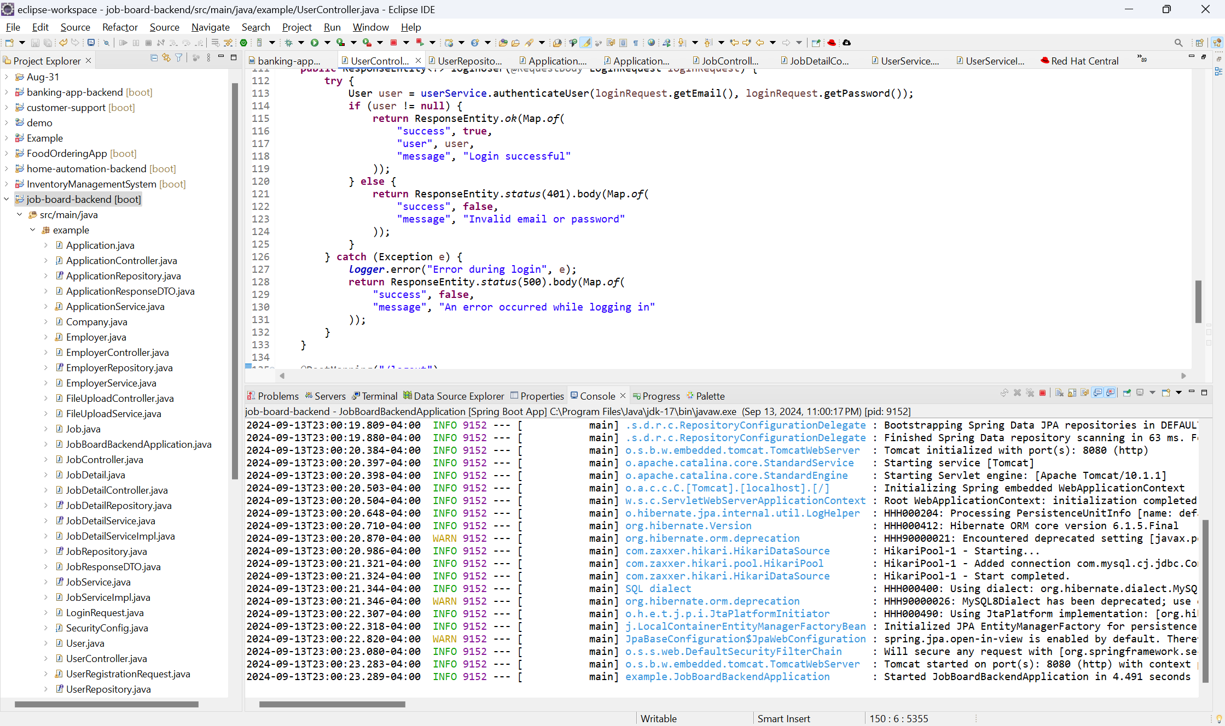

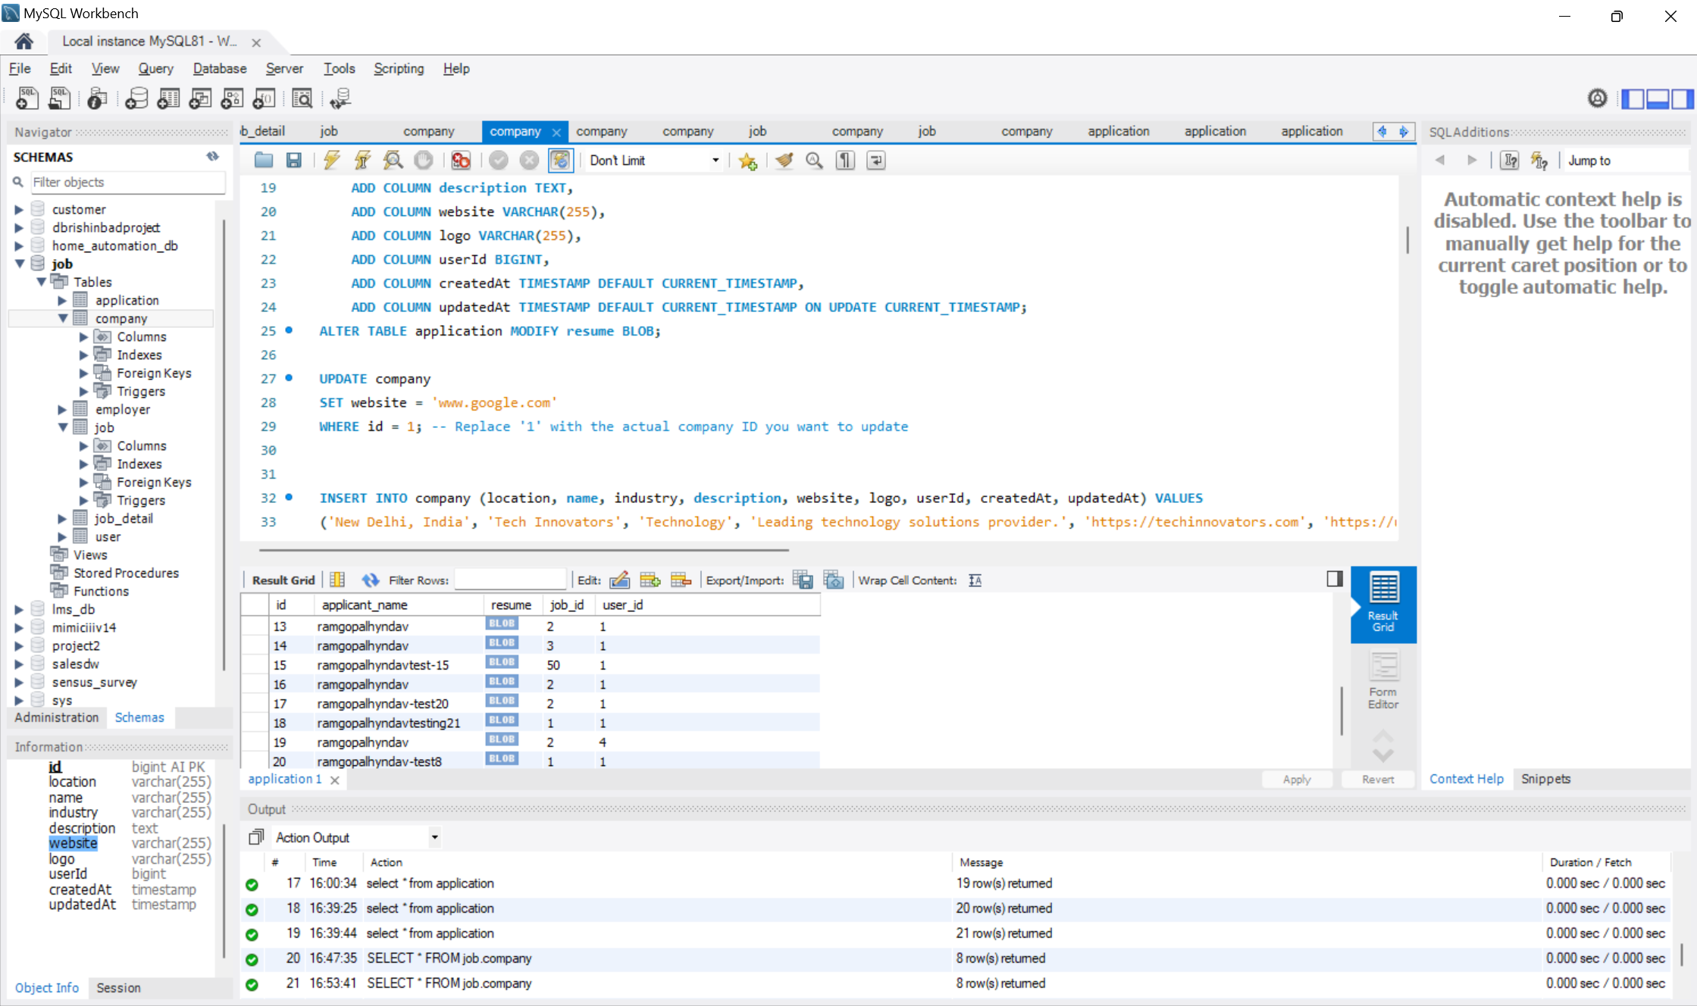

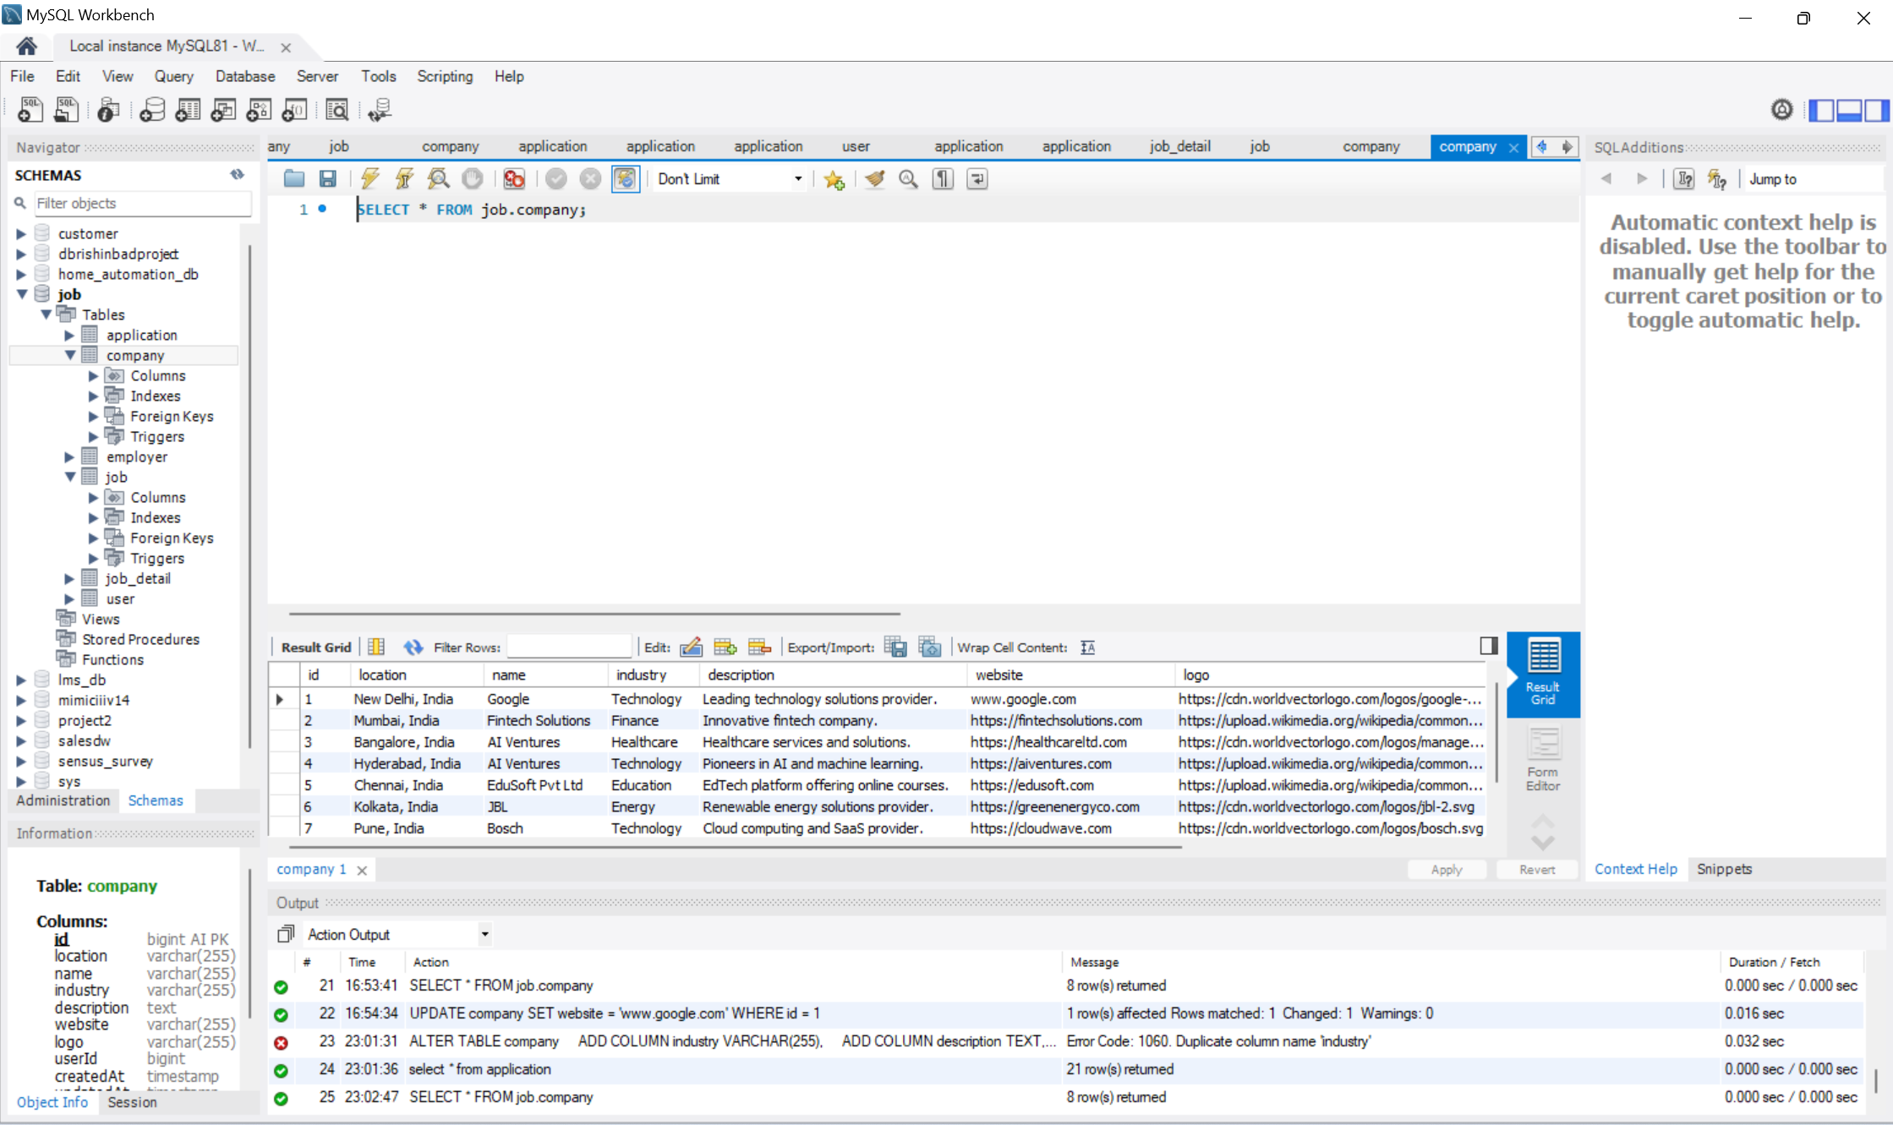

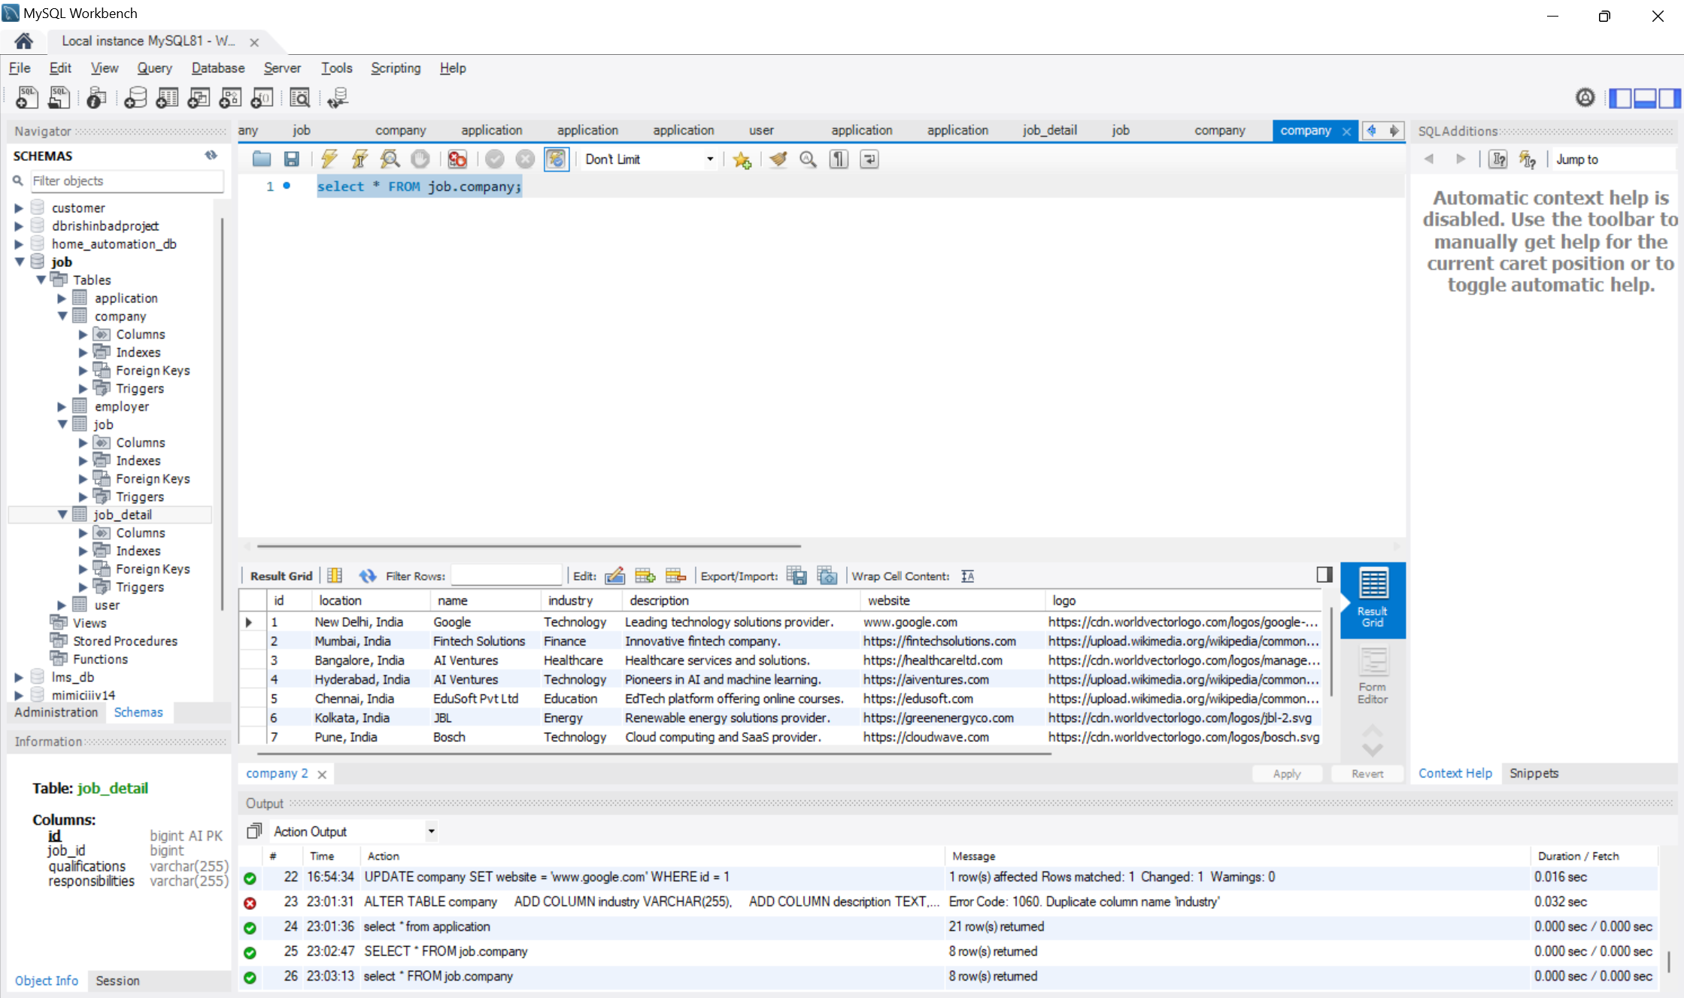

**5. Project Status Reports:**

**5.1 Format:**

1. **Overview:**The job board web application project is progressing steadily, with key components already developed, including backend API endpoints, database integration, and initial frontend setup. Current efforts focus on integrating the frontend with backend APIs, enhancing user interface features, and thorough testing to ensure a seamless user experience. The project is on track, with adjustments being made to address any issues or delays encountered during development. Upcoming tasks include finalizing all functionalities and preparing the application for deployment.
2. **Completed Tasks:** Developed backend API endpoints for job postings, user applications, and user management.Integrated MySQL database to handle user and job data.Setting up initial React frontend for job search, application submission, and profile management
3. **Ongoing Tasks:** Integrating frontend with backend APIs for seamless data communication. Enhancing frontend to enable job posting functionality.
4. **Pending Tasks:** Need to improve UI/UX design and Prepare for deployment.
5. **Issues and Challenges:** Ensuring smooth integration between the backend and frontend while maintaining data consistency and correctly formatting all stored data has been challenging. Additionally, resolving unexpected bugs and handling API communication efficiently has required focused debugging efforts.
6. **Next Steps:** Finalize the integration of the job posting functionality in the frontend, enabling recruiters to seamlessly create and manage job listings. Ensure that the interface is intuitive and fully aligned with backend APIs for a smooth user experience.

**6. Final Deliverables and Closure Report:**

**6.1 Summary of Outcomes:**

* 1. The job board application meets all defined functional and non-functional requirements.
  2. The backend API is robust and secure, handling authentication, job management, and application processing.
  3. The frontend is responsive and user-friendly, offering a seamless experience for both job seekers and recruiters.

**6.2 Collaborative Reviews**

* 1. Regular sprint reviews and feedback sessions with stakeholders to ensure alignment on features and deliverables.

**6.3 Final Code:**

**ApplicationController:**

package example;

import org.springframework.beans.factory.annotation.Autowired;

import org.springframework.http.HttpHeaders;

import org.springframework.http.HttpStatus;

import org.springframework.http.MediaType;

import org.springframework.http.ResponseEntity;

import org.springframework.web.bind.annotation.*;

import org.springframework.web.multipart.MultipartFile;

import java.io.IOException;

import java.util.List;

import java.util.stream.Collectors;

@CrossOrigin(origins = "http://localhost:5173")

@RestController

@RequestMapping("/api/applications")

public class ApplicationController {

@Autowired

private ApplicationService applicationService;

@Autowired

private JobService jobService;

@Autowired

private UserService userService; // Add this line to inject the UserService

@GetMapping("/user/{userId}/applications")

public ResponseEntity<List<ApplicationResponseDTO>> getApplicationsByUserId(@PathVariable Long userId) {

try {

List<Application> applications = applicationService.getApplicationsByUserId(userId);

if (applications == null || applications.isEmpty()) {

return new ResponseEntity<>(HttpStatus.*NO_CONTENT*);

}

// Convert Application entities to DTOs

List<ApplicationResponseDTO> applicationDTOs = applications.stream()

.map(application -> new ApplicationResponseDTO(

application.getId(),

application.getApplicantName(),

application.getResume(),

application.getJob() != null ? application.getJob().getTitle() : "N/A",

application.getJob() != null ? application.getJob().getCompany().getName() : "N/A",

application.getJob() != null ? application.getJob().getCreatedAt() : null))

.collect(Collectors.*toList*());

return new ResponseEntity<>(applicationDTOs, HttpStatus.*OK*);

} catch (Exception e) {

System.*err*.println("Error fetching applications: " + e.getMessage());

return new ResponseEntity<>(HttpStatus.*INTERNAL_SERVER_ERROR*);

}

}

@GetMapping("/{id}")

public ResponseEntity<ApplicationResponseDTO> getApplicationById(@PathVariable Long id) {

Application application = applicationService.getApplicationById(id);

if (application != null) {

Job job = application.getJob();

ApplicationResponseDTO applicationDTO = new ApplicationResponseDTO(

application.getId(),

application.getApplicantName(),

null,

job != null ? job.getTitle() : "N/A",

job != null ? job.getCompany().getName() : "N/A",

job != null ? job.getCreatedAt() : null

);

return new ResponseEntity<>(applicationDTO, HttpStatus.*OK*);

} else {

return new ResponseEntity<>(HttpStatus.*NOT_FOUND*);

}

}

@GetMapping("/resume/{id}")

public ResponseEntity<byte[]> downloadResume(@PathVariable Long id) {

Application application = applicationService.getApplicationById(id);

if (application != null && application.getResume() != null) {

HttpHeaders headers = new HttpHeaders();

headers.setContentType(MediaType.*APPLICATION_PDF*);

headers.setContentDispositionFormData("attachment", "resume_" + application.getId() + ".pdf");

return new ResponseEntity<>(application.getResume(), headers, HttpStatus.*OK*);

} else {

return new ResponseEntity<>(HttpStatus.*NOT_FOUND*);

}

}

@PostMapping("/apply/{jobId}")

public ResponseEntity<?> createApplication(

@PathVariable("jobId") Long jobId,

@RequestParam("applicantName") String applicantName,

@RequestParam("resume") MultipartFile resumeFile,

@RequestParam("userEmail") String userEmail,

@RequestParam("userId") Long userId) {

if (jobId == null) {

return new ResponseEntity<>("Job ID is required.", HttpStatus.*BAD_REQUEST*);

}

if (resumeFile == null || resumeFile.isEmpty()) {

return new ResponseEntity<>("Resume file is required.", HttpStatus.*BAD_REQUEST*);

}

try {

byte[] resumeData = resumeFile.getBytes();

Job job = jobService.getJobById(jobId);

if (job == null) {

return new ResponseEntity<>("Job not found.", HttpStatus.*NOT_FOUND*);

}

Application application = new Application();

application.setApplicantName(applicantName);

application.setJob(job);

application.setResume(resumeData);

// Set the user for this application using userId

User user = userService.findById(userId);

if (user == null) {

return new ResponseEntity<>("User not found.", HttpStatus.*NOT_FOUND*);

}

application.setUser(user);

applicationService.saveApplication(application, userEmail);

int totalApplicants = applicationService.countApplicationsByJobId(jobId);

job.setApplicationsCount(totalApplicants);

jobService.saveJob(job);

Job updatedJob = jobService.getJobById(jobId);

return ResponseEntity.*status*(HttpStatus.*CREATED*).body(updatedJob);

} catch (IOException e) {

return new ResponseEntity<>("Failed to upload file.", HttpStatus.*INTERNAL_SERVER_ERROR*);

} catch (IllegalArgumentException e) {

return new ResponseEntity<>(e.getMessage(), HttpStatus.*BAD_REQUEST*);

} catch (Exception e) {

return new ResponseEntity<>("An unexpected error occurred.", HttpStatus.*INTERNAL_SERVER_ERROR*);

}

}

}

**JobController:**

package example;

import org.springframework.beans.factory.annotation.Autowired;

import org.springframework.http.HttpStatus;

import org.springframework.http.ResponseEntity;

import org.springframework.web.bind.annotation.*;

import java.util.List;

@CrossOrigin(origins = "http://localhost:5173")

@RestController

@RequestMapping("/api/jobs")

public class JobController {

@Autowired

private JobService jobService;

@GetMapping

public ResponseEntity<List<JobResponseDTO>> getAllJobs() {

List<JobResponseDTO> jobs = jobService.getAllJobs();

return new ResponseEntity<>(jobs, HttpStatus.OK);

}

@GetMapping("/{id}")

public ResponseEntity<JobResponseDTO> getJobById(@PathVariable Long id) {

Job job = jobService.getJobById(id);

if (job != null) {

return new ResponseEntity<>(new JobResponseDTO(job), HttpStatus.OK);

} else {

return new ResponseEntity<>(HttpStatus.NOT_FOUND); // Return 404 if not found

}

}

@PostMapping

public ResponseEntity<Job> createJob(@RequestBody Job job) {

Job createdJob = jobService.saveJob(job);

return new ResponseEntity<>(createdJob, HttpStatus.CREATED);

}

@PutMapping("/{id}")

public ResponseEntity<Job> updateJob(@PathVariable Long id, @RequestBody Job job) {

job.setId(id);

Job updatedJob = jobService.saveJob(job);

return new ResponseEntity<>(updatedJob, HttpStatus.OK);

}

@DeleteMapping("/{id}")

public ResponseEntity<Void> deleteJob(@PathVariable Long id) {

jobService.deleteJob(id);

return new ResponseEntity<>(HttpStatus.NO_CONTENT);

}

}

JobDetailController:

package example;

import org.springframework.beans.factory.annotation.Autowired;

import org.springframework.web.bind.annotation.*;

import java.util.List;

@RestController

@RequestMapping("/api/job-details")

public class JobDetailController {

@Autowired

private JobDetailService jobDetailService;

@GetMapping

public List<JobDetail> getAllJobDetails() {

return jobDetailService.getAllJobDetails();

}

@GetMapping("/{id}")

public JobDetail getJobDetailById(@PathVariable Long id) {

return jobDetailService.getJobDetailById(id);

}

@PostMapping

public JobDetail createJobDetail(@RequestBody JobDetail jobDetail) {

return jobDetailService.saveJobDetail(jobDetail);

}

@PutMapping("/{id}")

public JobDetail updateJobDetail(@PathVariable Long id, @RequestBody JobDetail jobDetail) {

jobDetail.setId(id);

return jobDetailService.saveJobDetail(jobDetail);

}

@DeleteMapping("/{id}")

public void deleteJobDetail(@PathVariable Long id) {

jobDetailService.deleteJobDetail(id);

}

}

**UserController:**

package example;

import org.springframework.beans.factory.annotation.Autowired;

import org.springframework.http.HttpStatus;

import org.springframework.http.ResponseEntity;

import org.springframework.web.bind.annotation.*;

import org.springframework.web.multipart.MultipartFile;

import org.springframework.security.crypto.password.PasswordEncoder;

import org.slf4j.Logger;

import org.slf4j.LoggerFactory;

import java.util.Map;

@RestController

@RequestMapping("/api/users")

public class UserController {

@Autowired

private UserService userService;

@Autowired

private PasswordEncoder passwordEncoder;

@Autowired

private FileUploadService fileUploadService;

private static final Logger *logger* = LoggerFactory.*getLogger*(UserController.class);

@PostMapping("/register")

public ResponseEntity<?> registerUser(

@RequestParam String fullname,

@RequestParam String email,

@RequestParam String phoneNumber,

@RequestParam String password,

@RequestParam String role,

@RequestParam(required = false) MultipartFile file) {

try {

// Check if the email is already in use

if (userService.existsByEmail(email)) {

return ResponseEntity.*badRequest*().body(Map.*of*(

"success", false,

"message", "Email is already in use"

));

}

// Handle file upload using the service

String filePath = null;

if (file != null && !file.isEmpty()) {

filePath = fileUploadService.saveFile(file);

}

// Create and save the user

User user = new User();

user.setFullname(fullname);

user.setEmail(email);

user.setPhoneNumber(phoneNumber);

user.setPassword(passwordEncoder.encode(password));

user.setRole(role);

user.setProfilePicture(filePath);

User savedUser = userService.saveUser(user);

// Ensure user is saved correctly

if (savedUser.getId() == null) {

return ResponseEntity.*status*(500).body(Map.*of*(

"success", false,

"message", "User could not be saved"

));

}

return ResponseEntity.*ok*(Map.*of*(

"success", true,

"user", savedUser,

"message", "User registered successfully"

));

} catch (Exception e) {

*logger*.error("Error registering user", e);

return ResponseEntity.*status*(500).body(Map.*of*(

"success", false,

"message", "An error occurred while registering the user"

));

}

}

@GetMapping("/email/{email}")

public ResponseEntity<?> getUserByEmail(@PathVariable String email) {

try {

User user = userService.getUserByEmail(email);

if (user != null) {

return ResponseEntity.*ok*(Map.*of*(

"success", true,

"user", user

));

} else {

return ResponseEntity.*status*(HttpStatus.*NOT_FOUND*).body(Map.*of*(

"success", false,

"message", "User not found"

));

}

} catch (Exception e) {

*logger*.error("Error fetching user by email", e);

return ResponseEntity.*status*(HttpStatus.*INTERNAL_SERVER_ERROR*).body(Map.*of*(

"success", false,

"message", "An error occurred while fetching the user"

));

}

}

@PostMapping("/login")

public ResponseEntity<?> loginUser(@RequestBody LoginRequest loginRequest) {

try {

User user = userService.authenticateUser(loginRequest.getEmail(), loginRequest.getPassword());

if (user != null) {

return ResponseEntity.*ok*(Map.*of*(

"success", true,

"user", user,

"message", "Login successful"

));

} else {

return ResponseEntity.*status*(401).body(Map.*of*(

"success", false,

"message", "Invalid email or password"

));

}

} catch (Exception e) {

*logger*.error("Error during login", e);

return ResponseEntity.*status*(500).body(Map.*of*(

"success", false,

"message", "An error occurred while logging in"

));

}

}

@PostMapping("/logout")

public ResponseEntity<?> logoutUser() {

try {

// Implement logout logic, such as invalidating the session or clearing cookies

return ResponseEntity.*ok*(Map.*of*(

"success", true,

"message", "Logout successful"

));

} catch (Exception e) {

*logger*.error("Error during logout", e);

return ResponseEntity.*status*(500).body(Map.*of*(

"success", false,

"message", "An error occurred while logging out"

));

}

}

}

**REACT:**

JobDescription:  
import React, { useEffect } from 'react';

import { Badge } from './ui/badge';

import { Button } from './ui/button';

import { useParams, useNavigate } from 'react-router-dom';

import axios from 'axios';

import { JOB_API_END_POINT } from '@/utils/constant';

import { setSingleJob } from '@/redux/jobSlice';

import { useDispatch, useSelector } from 'react-redux';

import { toast } from 'sonner';

const JobDescription = () => {

  const { singleJob } = useSelector((store) => store.job);

  const { user } = useSelector((store) => store.auth);

  const dispatch = useDispatch();

  const navigate = useNavigate();

  const { id: jobId } = useParams();

  const fetchJobDetails = async () => {

    console.log('Fetching job details for ID:', jobId);

    if (!jobId) return;

    try {

      const res = await axios.get(`${JOB_API_END_POINT}/${jobId}`, { withCredentials: true });

      if (res.data && res.status === 200) {

        dispatch(setSingleJob(res.data));

      } else {

        toast.error('Failed to fetch job details');

      }

    } catch (error) {

      console.error('Error fetching job:', error);

      toast.error('Error fetching job details');

    }

  };

  const applyJobHandler = () => {

    if (!user) {

      toast.error('Please log in to apply for this job.');

      return;

    }

    navigate(`/apply/${jobId}`);

  };

  useEffect(() => {

    fetchJobDetails();

  }, [jobId, dispatch]);

  return (

    <div className="max-w-7xl mx-auto my-10 p-6 bg-white shadow-lg rounded-lg">

      <div className="flex items-center justify-between border-b pb-4 mb-4">

        <div>

          <h1 className="text-2xl font-bold text-gray-800">{singleJob?.title}</h1>

          <div className="flex items-center gap-2 mt-3">

            <Badge className="bg-blue-100 text-blue-800">{singleJob?.position} Positions</Badge>

            <Badge className="bg-red-100 text-red-800">{singleJob?.jobType}</Badge>

            <Badge className="bg-purple-100 text-purple-800">{singleJob?.salary} LPA</Badge>

            <Badge className="bg-green-100 text-green-800">Total Applicants: {singleJob?.applications?.length}</Badge>

          </div>

        </div>

        <Button

          onClick={applyJobHandler}

          className="rounded-lg bg-purple-600 hover:bg-purple-700 text-white shadow-lg px-6 py-2 transition duration-300"

        >

          APPLY

        </Button>

      </div>

      <div className="space-y-4">

        <h2 className="text-xl font-semibold text-gray-700">Job Details</h2>

        <div className="space-y-2">

          <p className="text-lg"><span className="font-semibold">Role:</span> <span className="text-gray-600">{singleJob?.title}</span></p>

          <p className="text-lg"><span className="font-semibold">Location:</span> <span className="text-gray-600">{singleJob?.location}</span></p>

          <p className="text-lg"><span className="font-semibold">Description:</span> <span className="text-gray-600">{singleJob?.description}</span></p>

          <p className="text-lg"><span className="font-semibold">Experience:</span> <span className="text-gray-600">{singleJob?.experience} yrs</span></p>

          <p className="text-lg"><span className="font-semibold">Salary:</span> <span className="text-gray-600">{singleJob?.salary} LPA</span></p>

          <p className="text-lg"><span className="font-semibold">Total Applicants:</span> <span className="text-gray-600">{singleJob?.applications?.length}</span></p>

          <p className="text-lg"><span className="font-semibold">Posted Date:</span> <span className="text-gray-600">{singleJob?.createdAt?.split('T')[0]}</span></p>

        </div>

        {/* Display Company Details */}

        {singleJob?.company && (

          <div className="mt-6 p-4 bg-gray-100 rounded-lg">

            <h2 className="text-xl font-semibold text-gray-700">Company Details</h2>

            <div className="flex items-center mt-2">

              {singleJob?.company?.logo && (

                <img src={singleJob.company.logo} alt="Company Logo" className="h-16 w-16 rounded-full mr-4" />

              )}

              <div>

                <p className="text-lg"><span className="font-semibold">Name:</span> <span className="text-gray-600">{singleJob?.company?.name}</span></p>

                <p className="text-lg"><span className="font-semibold">Location:</span> <span className="text-gray-600">{singleJob?.company?.location}</span></p>

                <p className="text-lg"><span className="font-semibold">Description:</span> <span className="text-gray-600">{singleJob?.company?.description}</span></p>

                {singleJob?.company?.website && (

                  <p className="text-lg"><span className="font-semibold">Website:</span> <a href={singleJob.company.website} target="_blank" rel="noopener noreferrer" className="text-blue-600 hover:underline">{singleJob.company.website}</a></p>

                )}

              </div>

            </div>

          </div>

        )}

      </div>

    </div>

  );

};

export default JobDescription;

**Profile:**

import React, { useState } from 'react'

import Navbar from './shared/Navbar'

import { Avatar, AvatarImage } from './ui/avatar'

import { Button } from './ui/button'

import { Contact, Mail, Pen } from 'lucide-react'

import { Badge } from './ui/badge'

import { Label } from './ui/label'

import AppliedJobTable from './AppliedJobTable'

import UpdateProfileDialog from './UpdateProfileDialog'

import { useSelector } from 'react-redux'

import useGetAppliedJobs from '@/hooks/useGetAppliedJobs'

// const skills = ["Html", "Css", "Javascript", "Reactjs"]

const isResume = true;

const Profile = () => {

    useGetAppliedJobs();

    const [open, setOpen] = useState(false);

    const {user} = useSelector(store=>store.auth);

    return (

        <div>

            <Navbar />

            <div className='max-w-4xl mx-auto bg-white border border-gray-200 rounded-2xl my-5 p-8'>

                <div className='flex justify-between'>

                    <div className='flex items-center gap-4'>

                        <Avatar className="h-24 w-24">

                            <AvatarImage src="https://www.shutterstock.com/image-vector/circle-line-simple-design-logo-600nw-2174926871.jpg" alt="profile" />

                        </Avatar>

                        <div>

                            <h1 className='font-medium text-xl'>{user?.fullname}</h1>

                            <p>{user?.profile?.bio}</p>

                        </div>

                    </div>

                    <Button onClick={() => setOpen(true)} className="text-right" variant="outline"><Pen /></Button>

                </div>

                <div className='my-5'>

                    <div className='flex items-center gap-3 my-2'>

                        <Mail />

                        <span>{user?.email}</span>

                    </div>

                    <div className='flex items-center gap-3 my-2'>

                        <Contact />

                        <span>{user?.phoneNumber}</span>

                    </div>

                </div>

                <div className='my-5'>

                    <h1>Skills</h1>

                    <div className='flex items-center gap-1'>

                        {

                            user?.profile?.skills.length !== 0 ? user?.profile?.skills.map((item, index) => <Badge key={index}>{item}</Badge>) : <span>NA</span>

                        }

                    </div>

                </div>

                <div className='grid w-full max-w-sm items-center gap-1.5'>

                    <Label className="text-md font-bold">Resume</Label>

                    {

                        isResume ? <a target='blank' href={user?.profile?.resume} className='text-blue-500 w-full hover:underline cursor-pointer'>{user?.profile?.resumeOriginalName}</a> : <span>NA</span>

                    }

                </div>

            </div>

            <div className='max-w-4xl mx-auto bg-white rounded-2xl'>

                <h1 className='font-bold text-lg my-5'>Applied Jobs</h1>

                {/* Applied Job Table   */}

                <AppliedJobTable />

            </div>

            <UpdateProfileDialog open={open} setOpen={setOpen}/>

        </div>

    )

}

**export default Profile**

**HeroSection:**import React, { useState } from 'react';

import { Button } from './ui/button';

import { Search } from 'lucide-react';

import { useDispatch } from 'react-redux';

import { setSearchedQuery } from '@/redux/jobSlice';

import { useNavigate } from 'react-router-dom';

const HeroSection = () => {

    const [query, setQuery] = useState("");

    const [location, setLocation] = useState("");

    const [industry, setIndustry] = useState("");

    const dispatch = useDispatch();

    const navigate = useNavigate();

    const searchJobHandler = () => {

        // Combine the search parameters into a single string for dispatch

        const searchQuery = `query:${query} location:${location} industry:${industry}`.trim();

        // Dispatch the search query

        dispatch(setSearchedQuery(searchQuery));

        navigate("/jobs");

    };

    return (

        <div

            className='relative bg-center text-white h-screen'

            style={{

                backgroundImage: `url('https://images.unsplash.com/photo-1713947506663-7f630ef496ba?q=80&w=2232&auto=format&fit=crop&ixlib=rb-4.0.3&ixid=M3wxMjA3fDB8MHxwaG90by1wYWdlfHx8fGVufDB8fHx8fA%3D%3D')`,

                backgroundSize: 'cover',

                backgroundPosition: 'center',

                backgroundRepeat: 'no-repeat'

            }}

        >

            <div className='absolute inset-0 bg-black opacity-50'></div> {/* Overlay */}

            <div className='relative z-10 flex flex-col items-center justify-center h-full text-center'>

                <h1 className='text-5xl font-bold leading-snug mb-4'>

                    Your Dream <span className='text-[#6A38C2]'>Job</span> is Waiting

                </h1>

                {/* Enhanced Search Bar */}

                <div className='relative w-full md:w-[70%] lg:w-[60%] xl:w-[50%] mx-auto mt-8'>

                    <div className='flex items-center gap-2 p-2 bg-white rounded-lg shadow-lg backdrop-blur-md bg-opacity-80'>

                        <input

                            type="text"

                            placeholder='Job Title (e.g. Graphic, Web Developer)'

                            onChange={(e) => setQuery(e.target.value)}

                            className='w-1/3 py-3 px-4 text-sm text-gray-800 bg-white outline-none rounded-md placeholder-gray-500 focus:ring-2 focus:ring-[#6A38C2] transition-colors duration-300 ease-in-out'

                        />

                        <input

                            type="text"

                            placeholder='Location (e.g. New York)'

                            onChange={(e) => setLocation(e.target.value)}

                            className='w-1/3 py-3 px-4 text-sm text-gray-800 bg-white outline-none rounded-md placeholder-gray-500 focus:ring-2 focus:ring-[#6A38C2] transition-colors duration-300 ease-in-out'

                        />

                        <input

                            type="text"

                            placeholder='Industry (e.g. Tech, Healthcare)'

                            onChange={(e) => setIndustry(e.target.value)}

                            className='w-1/3 py-3 px-4 text-sm text-gray-800 bg-white outline-none rounded-md placeholder-gray-500 focus:ring-2 focus:ring-[#6A38C2] transition-colors duration-300 ease-in-out'

                        />

                        <Button

                            onClick={searchJobHandler}

                            className="bg-[#6A38C2] hover:bg-purple-700 p-3 rounded-md text-white transition-all duration-300 flex items-center justify-center"

                        >

                            <Search className='h-5 w-5' />

                        </Button>

                    </div>

                </div>

            </div>

        </div>

    );

};

export default HeroSection;

**Jobs:**

import React, { useEffect, useState } from 'react';

import Navbar from './shared/Navbar';

import FilterCard from './FilterCard';

import Job from './Job';

import { useSelector } from 'react-redux';

import { motion } from 'framer-motion';

import axios from 'axios';

import { JOB_API_END_POINT } from '@/utils/constant';

const Jobs = () => {

  const { searchedQuery } = useSelector((store) => store.job);

  const [jobs, setJobs] = useState([]);

  const [filterJobs, setFilterJobs] = useState([]);

  // Fetching jobs from API

  useEffect(() => {

    const fetchJobs = async () => {

      try {

        const response = await axios.get(`${JOB_API_END_POINT}`);

        console.log('Fetched jobs:', response.data);

        if (Array.isArray(response.data)) {

          setJobs(response.data);

          setFilterJobs(response.data);

        } else {

          console.error('Unexpected API response format');

        }

      } catch (error) {

        console.error('Error fetching jobs:', error);

      }

    };

    fetchJobs();

  }, []);

  // Filter jobs based on the search query

  useEffect(() => {

    console.log('Searched Query:', searchedQuery);

    let filteredJobs = jobs;

    if (searchedQuery) {

      // Improved regex to handle multiple key-value pairs correctly

      const queryObj = Object.fromEntries(

        searchedQuery

          .split(' ')

          .map((item) => item.split(/:(.+)/).map((str) => str.trim()))

      );

      console.log('Query Object:', queryObj);

      const queryLocation = queryObj?.location?.toLowerCase();

      const queryPosition = queryObj?.position?.toLowerCase();

      const querySalary = queryObj?.salary;

      const queryJobType = queryObj?.job_type?.toLowerCase();

      // Apply filters

      filteredJobs = jobs.filter((job) => {

        const matchLocation = queryLocation ? job.location?.toLowerCase() === queryLocation : true;

        const matchPosition = queryPosition ? job.position?.toLowerCase().includes(queryPosition) : true;

        const matchSalary = querySalary ? isSalaryInRange(job.salary, querySalary) : true;

        const matchJobType = queryJobType ? job.jobType?.toLowerCase().includes(queryJobType) : true;

        return matchLocation && matchPosition && matchSalary && matchJobType;

      });

      console.log('Filtered Jobs:', filteredJobs);

    }

    setFilterJobs(filteredJobs);

  }, [searchedQuery, jobs]);

  const isSalaryInRange = (jobSalary, queryRange) => {

    const jobSalaryNumeric = extractSalaryValue(jobSalary);

    const [minRange, maxRange] = extractSalaryRange(queryRange);

    if (minRange === null || maxRange === null || jobSalaryNumeric === null) {

      return false;

    }

    return jobSalaryNumeric >= minRange && jobSalaryNumeric <= maxRange;

  };

  const extractSalaryValue = (salaryString) => {

    const salaryMatch = salaryString.match(/(\d+)\s*Lakh/);

    return salaryMatch ? parseInt(salaryMatch[1]) * 100000 : null;

  };

  const extractSalaryRange = (rangeString) => {

    if (rangeString.includes('Above')) {

      const min = parseInt(rangeString.match(/(\d+)\s*Lakh/)[1]);

      return [min * 100000, Infinity];

    }

    const rangeMatch = rangeString.match(/(\d+)\s*Lakh.*?(\d+)\s*Lakh/);

    return rangeMatch ? [parseInt(rangeMatch[1]) * 100000, parseInt(rangeMatch[2]) * 100000] : [null, null];

  };

  return (

    <div>

      <Navbar />

      <div className='max-w-7xl mx-auto mt-5'>

        <div className='flex gap-5'>

          <div className='w-1/5'>

            <FilterCard />

          </div>

          {filterJobs.length <= 0 ? (

            <span>No jobs found</span>

          ) : (

            <div className='flex-1 h-[88vh] overflow-y-auto pb-5'>

              <div className='grid grid-cols-3 gap-4'>

                {filterJobs.map((job) => (

                  <motion.div

                    initial={{ opacity: 0, x: 100 }}

                    animate={{ opacity: 1, x: 0 }}

                    exit={{ opacity: 0, x: -100 }}

                    transition={{ duration: 0.3 }}

                    key={job.id}

                  >

                    <Job job={job} />

                  </motion.div>

                ))}

              </div>

            </div>

          )}

        </div>

      </div>

    </div>

  );

};

export default Jobs;

**7. References:**

**Spring Boot Documentation:**

Used as a primary reference for creating and managing the backend RESTful APIs, handling HTTP requests, and integrating backend services.

Spring Boot Official Documentation

**MySQL Documentation:**

Referred for designing the relational database schema, managing database operations, and integrating MySQL with the Spring Boot backend.

MySQL Official Documentation

**React Documentation**

Utilized as a reference for developing the frontend user interface, creating React components, managing state, and handling user interactions.

React Official Documentation

**Redux Toolkit Documentation:**

Used for managing global state in the React application, including user authentication, job listings, and search filters.

Redux Toolkit Official Documentation

**Axios Documentation**

Referenced for handling HTTP requests and responses between the React frontend and Spring Boot backend.

Axios GitHub Repository

**React Toastify Documentation:**

Used to implement toast notifications in the application, providing feedback to users on actions like login, logout, job application, and form submissions.

**Vite.js Documentation:**

Used to set up and manage the development environment for the React frontend, ensuring fast build times and optimized performance.

Vite.js Official Documentation

**Personal Development Experience:**

Personal knowledge and experience in Java, Spring Boot, MySQL, and React were extensively used to design, implement, and troubleshoot the application.

Project Prompts and Instructions

**8. Details**

Ramgopalhyndav Bollepalli

[Bollepalliramgopalhyndav@gmail.com](mailto:Bollepalliramgopalhyndav@gmail.com)  
9550753429